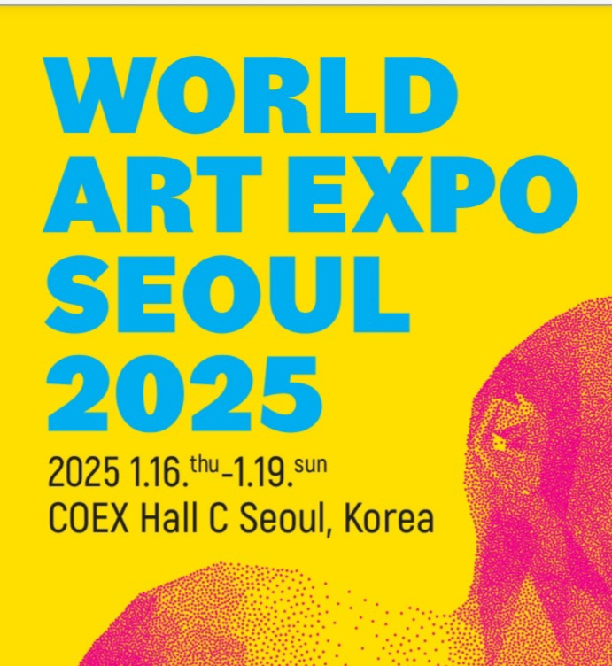

**16-19, JAN, 2025- SEOUL, KOREA**

Application

World Art Expo Seoul Organizing Committee 2025

iaawae23@gmail.com

**Application**

Terms & Venue: Jan16-19, 2025(Seoul COEX, C Hall)

Special application period: Until October31, 2024(Thu) (10% discount)

General application deadline: November 30, 2024

**Gallery Information**

(All Information entered in the application form will be used as the offline materials for the promotion of the World Expo Seoul 2025.)

|  |  |  |  |
| --- | --- | --- | --- |
| Gallery name |  | | |
| Representative |  | | |
| Manager |  | Contact Phone  Number |  |
| Gallery  Phone number |  | | |
| Address |  | | |
| Fax |  | | |
| E-mail |  | | |
| Web-site |  | | |
| Company  Registration  Number |  | | |

**Booth selection**

|  |  |  |  |  |
| --- | --- | --- | --- | --- |
| Booth | Size(m) | Area(㎡) | Base Price | Select |
| **A** | 4x6x4 | **24m2** | **4,450USD** | **󠇮** |
| **B** | 4x8x4 | **32m2** | **5,200USD** | **󠇮** |
| **C** | 5x10x5(outer wall) | **50m2** | **7,400USD** | **󠇮** |
|  | **10x20x10** | **200m2** | **Separate Inquiry** | **󠇮** |

The number of artists participating in booth A is limited to 5 or less (excluding tax)

**ㅣExceptional Benefits For Foreign GalleriesㅣHotel Accommodations (Guide of Recommendation – reasonable prices at staying for the participants)**

|  |  |
| --- | --- |
|  | *To reduce the burden of all the budget for the foreign participants, exceptionally Organizer will offer only the foreign gallery a discounted 50 percent off of the booth’s prices* |

★Website **https://www.wae.co.kr/**

**How to Payment(Bank Account No) after you will confirm the application**

|  |
| --- |
| **Name of Bank** : KOOKMIN  **Swift Code**: CZNBKRSE004  **Address**: #26, Gukjegeumyung-ro 8-gil, Yeongdeungpo-gu, Seoul, Korea  **Deposit Account**: **649701-01-310364**  **Account Holder**: Lee, Eun Ji (World ArtExpo Seoul)  **Payment of Installment:**  1 Step Payment terms (When the gallery apply in participation-50)  2 Step Payment terms ( All the payment should be Before 30, November) |

**PAYMENT PROCESS**

Payment

Do not forget pay your deposit and application fee if requested by the fair

In case your application is not successful, the deposit fee will be returned to the account number filled in under My Account.

Application Fee

Yes, USD 150+VAT where applicable

Deposit due with Submission

Yes, USD 1,000 +VAT where applicable

Payment Details

For international Galleries (Overseas) the totals will be **USD1.000**

Bank Reference

Please always quote your gallery name and ART FAIR DAEGU 2023 as reference,

If you’re sending from the foreign country, you must use the SWIFT codes

**Account Holder:**

**Routing Number:**

**Account Number:**

**BIC, SWIFT Code:**

**Bank Address:**

**Address:**

**Gallery Introduction**

|  |
| --- |
|  |

**List of Exhibited Artists**

|  |
| --- |
|  |

**Exhibition Details (last year)**

|  |
| --- |
|  |

**Participation in other Art Fairs**

|  |
| --- |
|  |

※**Submission materials; A copy of the participation application form and business registration certificate is attached *(required)**

I agree to the World Art Expo Seoul 2025 Terms and conditions for participation, also apply to the participation in the same manner above.

Date Month 2024

Gallery Name: Representative: (sign)